**3 RESULT**

**SIGN IN PAGE:**

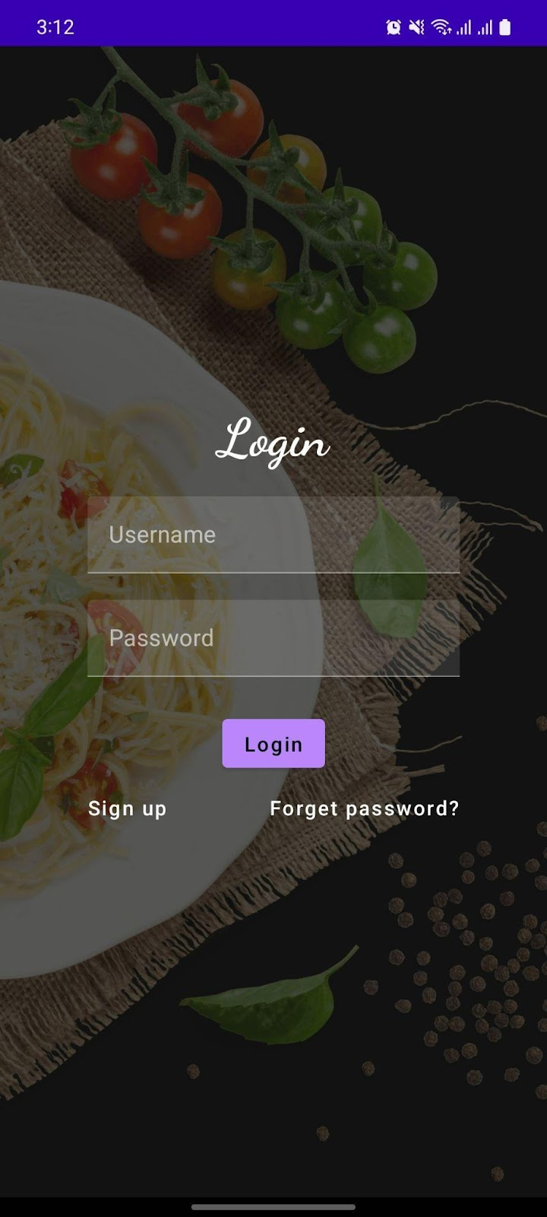

**SIGN UP PAGE:**

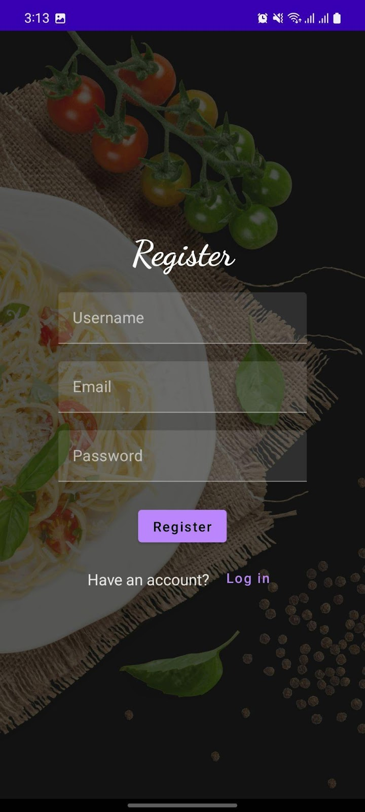

**ADMIN PAGE:**

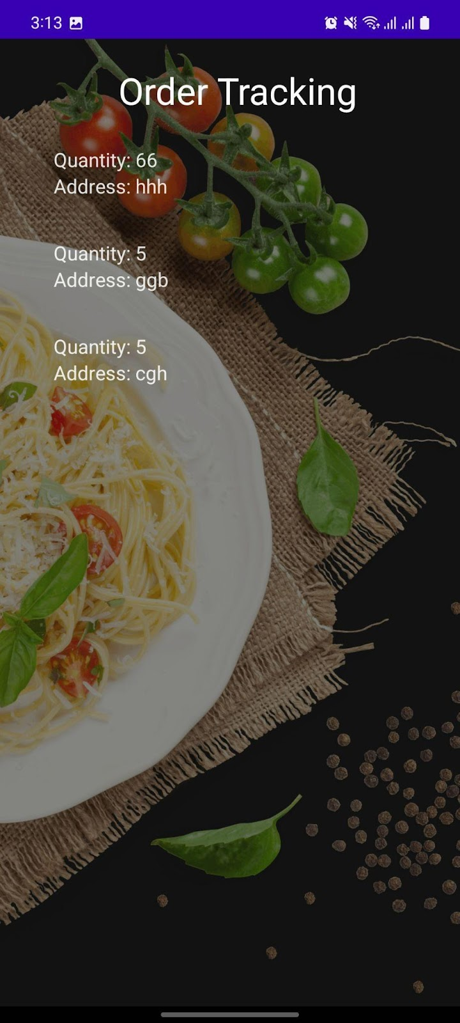

**USER PAGE:**

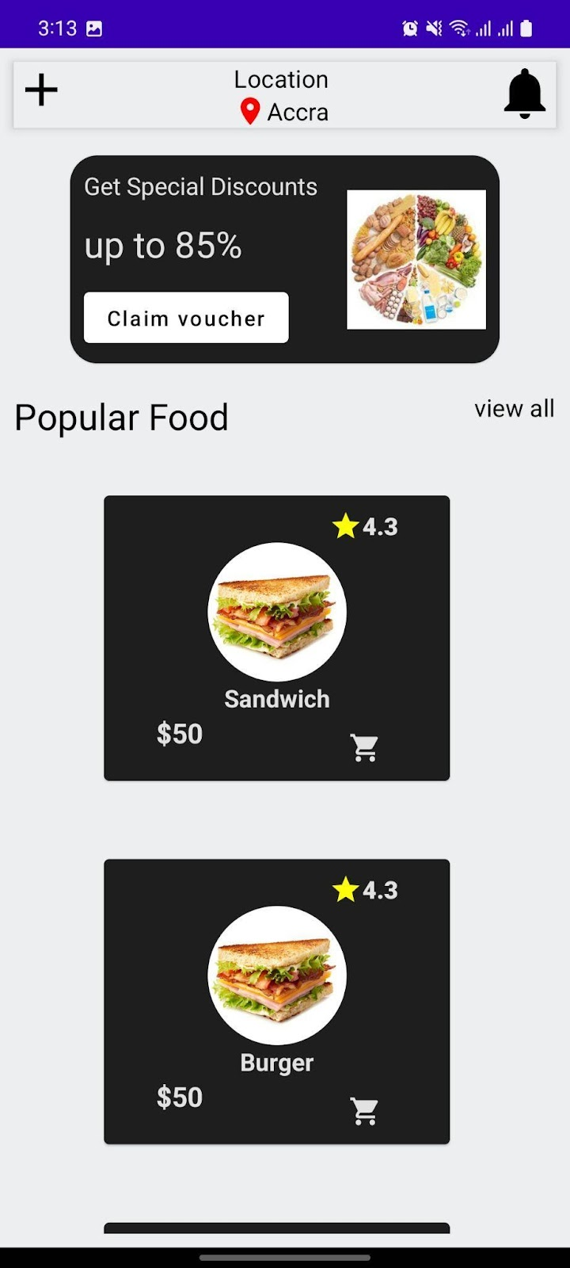

**ORDER PAGE:**

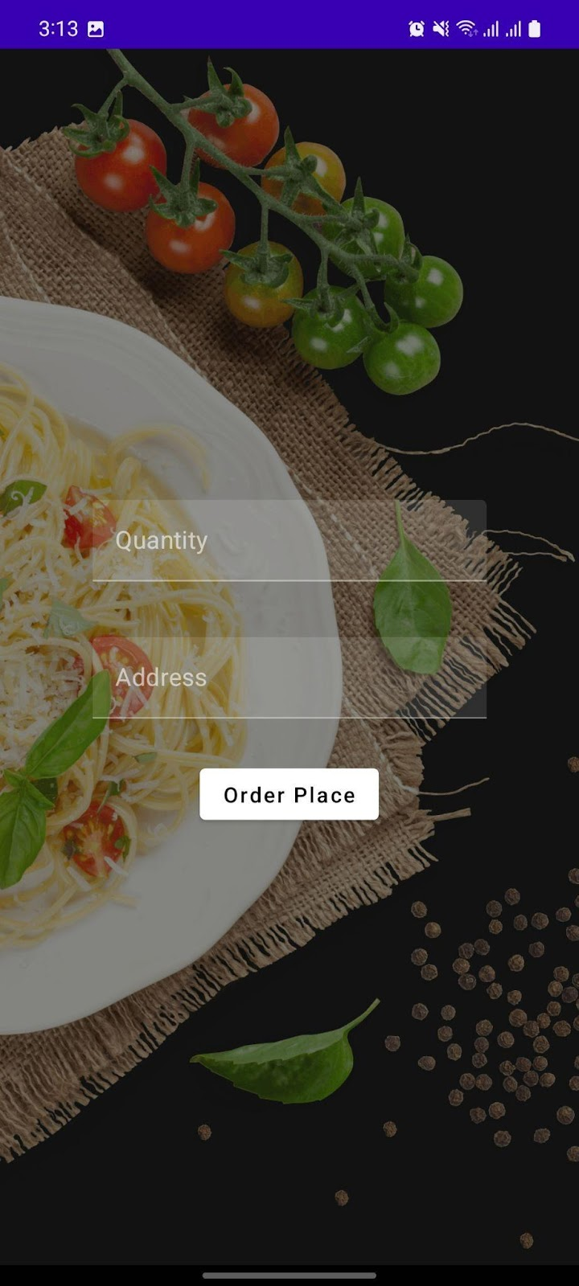**b**